For Office Use Only:
Date Received: ____________
Update UB: ____________
Initials: ____________

Third Party Notification Form
Upon receipt of this signed form, the Moose Lake Water and Light Commission will send the Landlord/Owner a disconnect notice at the same time one is sent to the Renter, should this property become subject to disconnection of electrical service.

Account Number: _______________________________________________
Service Address: _______________________________________________

_______________________________________________

Landlord/Owner Renter

Name ________________________ Name ________________________

Address ______________________ Address ______________________

_____________________________ _____________________________

Phone _______________________ Phone _______________________

Landlord Signature: Renter Signature:

_____________________________ _____________________________

Date _________________________ Date _________________________

Moose Lake Power
P.O. Box 418, Moose Lake, MN 55767 ♦ (218) 485-4100 ♦ Fax (218) 485-8729
www.mooselakepower.com

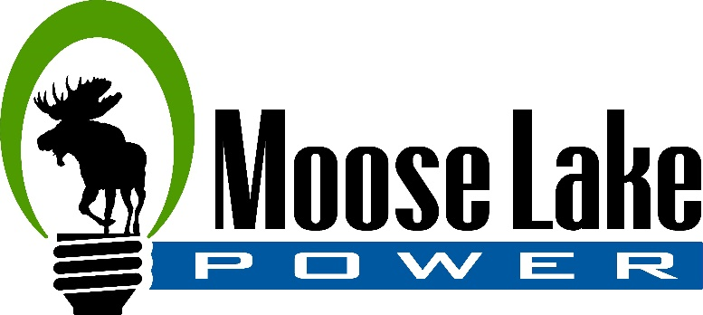

Dear Landlord,

Managing rental property can be time-consuming and costly. The cost of maintaining rental units and managing the utility services of tenants is considerable as people are more mobile than ever before. The Moose Lake Water and Light Commission would like to help reduce the hassle and costs with the enclosed Third Party Notification Form.
The Third Party Notification Form directs the Moose Lake Water and Light Commission to automatically notify landlords and/or owners of a disconnect notice, should this property become subject to a disconnection of electrical service.
In an attempt to get the landlord/tenant records updated, we ask for your cooperation in having you and your current tenant fill out the Third Party Notification Form, and return it to our office.
The Moose Lake Water and Light Commission suggests that when a new tenant moves into your rental property, an updated Third Party Notification Form be filled out and returned to our office. These forms can be obtained from our office.
Thank you in advance for your cooperation, and if you have any questions, please feel free to call (218)485-4100.
Sincerely,

Moose Lake Power

P.O. Box 418, Moose Lake, MN 55767 ♦ (218) 485-4100 ♦ Fax (218) 485-8729
www.mooselakepower.com

